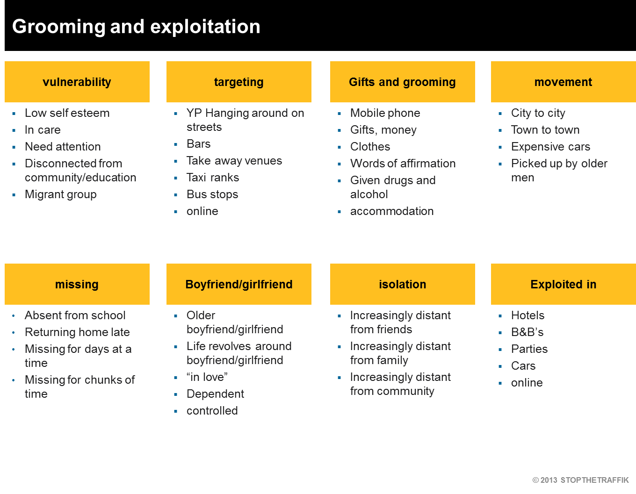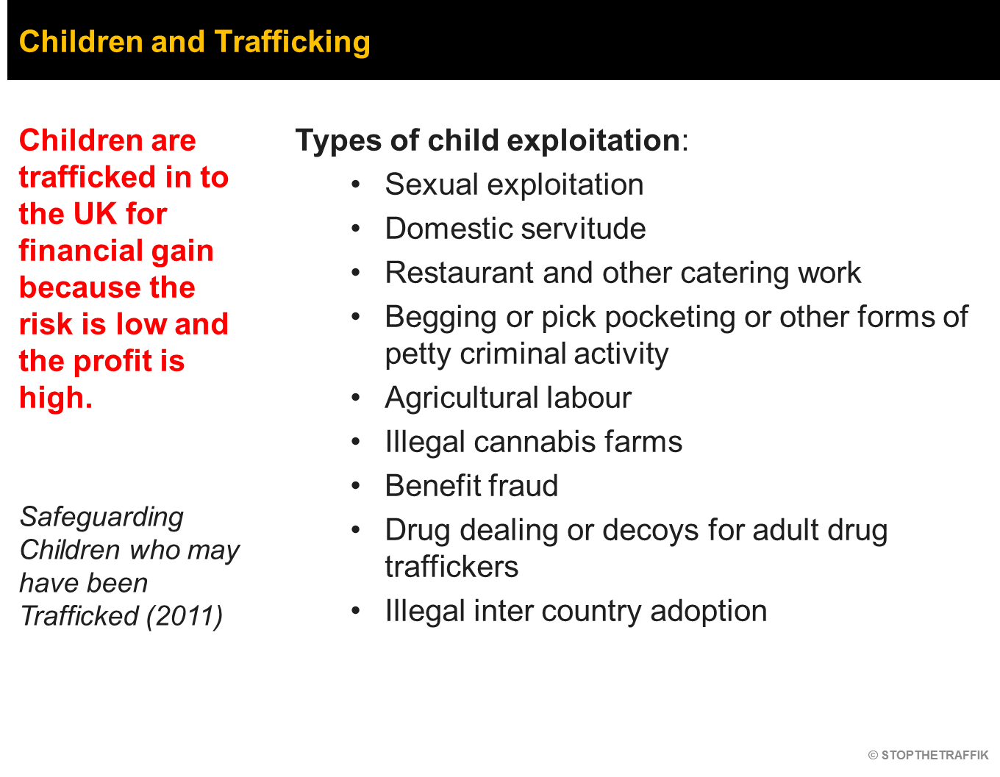
Children & young people can be vulnerable to manipulation and used as distraction for other types of crime. Because of this they are more likely to be picked up and charged by police for engaging in illegal activities. STT have done training in youth detention centres that after training identified trafficking victims.
